Ujian Akhir Praktikum - Semester Genap 2019/2020
Practicum Final Exam - Even Semester Year 2019/2020
Matakuliah  Subject |  |  | COMP6175 - Object Oriented Programming  MOBI6002 - Mobile Object Oriented Programming |  |  | 
Kelas  Class | : | B001 / B201 / B601 / B901 / BA01 / BA03 / BA26 / BC01 / BE01 / BG01 / BI01 / BL01 / BM01 / BT01 / BU01 / BX01 / BY01 / SB01 |  | Tanggal Mulai  Start Date | : 18 June 2020
Kelas  Class | : |  |  | Waktu Mulai  Start Time | : 11:20
Dosen  Lecturer | : | D0208 - Drs. Agus Prahono, M.Eng.Sc.  D1828 - Hendra, S.Kom., M.T.  D2425 - Ir. Yasri, M.T.  D3174 - Dr. Budi Yulianto, S.Kom., M.M., CBA.  D3757 - Tegar Aryo Sulthon Musthofa, S.Kom, M.MSI  D4653 - Eka Cahyadi, S.Kom., M.TI  D5094 - Aswin Wibisurya, S.Kom, M.TI  D5358 - Livia Ashianti, S.Kom., M.TI |  | Tanggal Selesai  End Date | : 19 June 2020
Dosen  Lecturer | : |  |  | Waktu Selesai  End Time | : 11:20

PERATURAN UJIAN:
Exam Regulations:
- Mahasiswa tidak diperbolehkan berdiskusi dan/atau bekerja sama dengan peserta ujian lainnya
Student is not allowed to discuss and/or work together with other exam participants
- Mahasiswa tidak diperbolehkan menyalin jawaban dari intenet
Student is not allowed to copy answer from the intenet
- Asisten BERHAK memberi nilai 0 (NOL) bagi peserta ujian yang melakukan segala bentuk kecurangan
Assistant is able to give 0 (ZERO) score for exam participant who does any cheating actions
- Kumpulkan jawaban tepat pada waktunya di https://laboratory.binus.ac.id/lab
Submit the answer on time at https://laboratory.binus.ac.id/lab
- Bila Anda tidak membaca peraturan ini, maka Anda dianggap telah membaca dan menyetujuinya
If you have missed to read these regulations, so you are considered to have read and agreed on it

SOFTWARE YANG DIGUNAKAN:
Software will be used:
- Java 8
- Eclipse Neon 3

FILE YANG DIKUMPULKAN:
File must be collected:
- Folder Project:
- Bin Folder (.CLASS)
- Src Folder (.JAVA)

PERHATIAN!
Attention!
- Bagi yang mengerjakan tidak sesuai dengan soal, maka akan diberikan nilai NOL (0)
For those who do not work in accordance with the exam case will be marked as ZERO (0)
- Bagi yang mengerjakan tidak sesuai dengan software dan versi yang telah ditetapkan, maka akan tetap dikoreksi dengan software dan versi yang telah ditetapkan
For those who do not work in accordance with the software and specific version will be corrected by the predefined software and version
- Kompres semua jawaban yang akan diunggah. Pastikan format pengumpulan nama file dan ekstensi sesuai dengan format berikut: [NIM]-[NAMA].zip
Compress all file that will be uploaded. Make sure the format for collecting file name and extension according to the following format: [NIM]-[NAME].zip

Soal
Case

Danbam
Criteria:
- Abstract Class
You need to design at least three classes, one abstract class, and two concrete classes. The abstract class consists of all common attributes and behavior that both concrete classes had. The concrete class consist of specific attribute and behavior that is not common between the two concrete classes.
- Encapsulation
To hide the data of a class from illegal direct access, all the attributes of the class must be encapsulated and will be accessed using an accessor and mutator that may perform validation before accessing the encapsulated attribute.
- Inheritance
All the concrete class must inherit all attribute and behavior from the abstract class
- Polymorphism
If the concrete class has a specific implementation of the inherited behavior (method) that differ from the abstract class, the concrete class can override or overload the behavior from the abstract class
- Composition
The composition concept in OOP is a strong relationship between objects that means some object must coexist together and cannot exist independently. The type of relationship with the composition concept is ‘part-of’. If any of the class contains other classes, then composition concept should be used to implement the feature
- Multi-Threading
Some of the processes must use multi-threading to make sure the process requirement runs smoothly. The multi-threading allows the program to run with different process timeline or simply run in the background

Danbam is a new successful korean restaurant opened in Itaewon, South Korea. You are asked to create a simulation game of Danbam’s daily transaction process using Java Base Programming. Danbam did not have any waiter as the customer is free to take any food provided in queue of menu made by the chef . The following criteria for the application are:
- Danbam’s initial process:
- Each object in the program have their own ID in the form of UUID (syntax: UUID.randomUUID()). In the beginning of the program, danbam has 1 chef, and 10 menus with the total money of 10000
- Chef Dummy Data
Chef Id | Username | Salary | Professional Status
UUID.randomUUID() | Park Sae Royi | 3000 | True
- Menu Dummy Data
Menu Id | Name | Price
UUID.randomUUID() | Kimchi Jjigae 김치찌개 | Random (500 - 1000)
UUID.randomUUID() | Jjinmandu 찐만두 | Random (500 - 1000)
UUID.randomUUID() | Daeji Bulgogi 불고기 | Random (500 - 1000)
UUID.randomUUID() | Gogigui 고기구이 | Random (500 - 1000)
UUID.randomUUID() | Haejangguk 해장국 | Random (500 - 1000)
UUID.randomUUID() | Sundubu Jjigae 순두부찌게 | Random (500 - 1000)
UUID.randomUUID() | Saengseon Jjigae 생선찌개 | Random (500 - 1000)
UUID.randomUUID() | Nakji Bokkeum 낙지볶음 | Random (500 - 1000)
UUID.randomUUID() | Seolleongtang 설렁탕 | Random (500 - 1000)
UUID.randomUUID() | Dolsot Bibimbap 돌솥 비빔밥 | Random (500 - 1000)

- Danbam’s background process using threading:
- Danbam has a queue of menu provided in the restaurant:
  - The queue of menu is empty at the beginning when the program starts, so, chef has to cook randomly from the menu in restaurant and add it into the queue
  - Each chef will add menu to the queue for every 1 or 2 seconds depending on their professionality
- Danbam only has a maximum of 5 seats in the restaurant and the customer will come until the seat full
  - Customers are free to choose randomly which menu in the queue that they want to enjoy. After the customer take a menu from the queue, remove that menu from the queue
  - Customers will enjoy the meal in 3 seconds and rest for a second while deciding whether they want to leave the restaurant or not (the percentage of leaving the restaurant is 10%)
  - If a customer not leaving the restaurant, they will choose another menu from the queue and keep eating
  - If a customer leaves the restaurant, they will pay for all the menu(s) in the queue that they have eaten (the payment will increase the total money of danbam and their history orders will be saved by the program for each customer) and another customer will come to the restaurant and enjoy the meal from the menu in the queue
- In the beginning, the program will show the menus and also the total money in Danbam. Remember, don't focus on designing the logo, just print “Danbam” it's enough
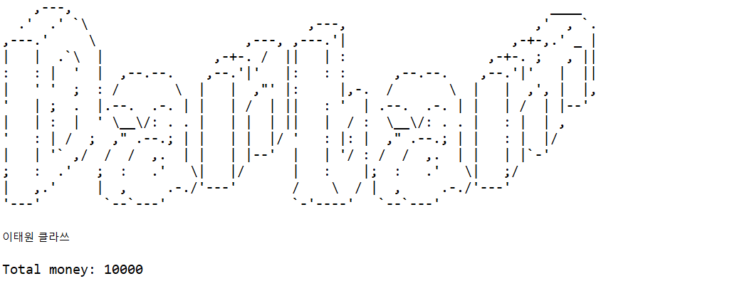
Figure 1. Main Menu Header
- The program will show 4 menus:
- Add danbam’s chef
- View danbam’s information
- View customers in danbam
- Quit
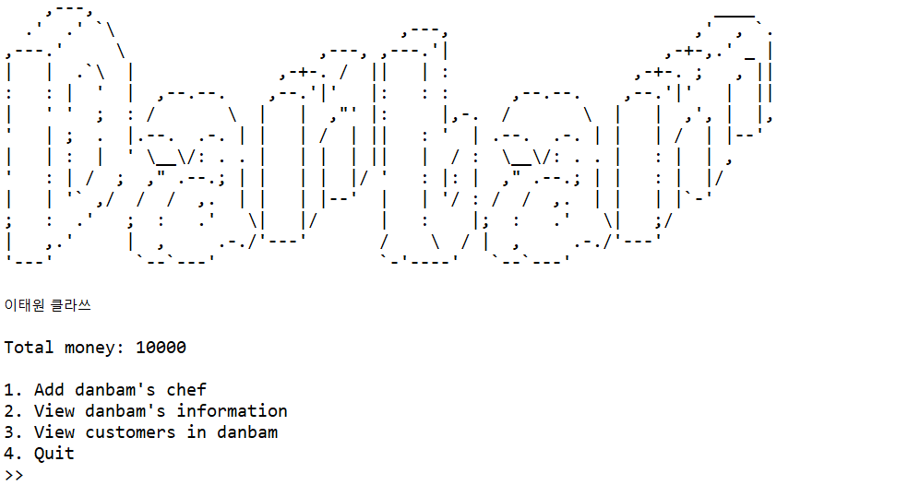
Figure 2. Main Menu
- If the user chooses menu 1 ‘Add danbam’s chef’, then:
- The program will ask the user to input the details of the chef:
- Chef’s name, which must consist of exact 3 words
- Chef’s username, which must be unique
- Chef’s gender, which must be between Female and Male (case sensitive)
- Chef’s age, which must be between 17 and 40
- After the details of the chef has been filled:
- Initialize the chef’s salary with 3000
- Random whether the chef is professional or not
- Generate Chef ID in the format of UUID (syntax: UUID.randomUUID())

- Then, add the new chef into the chef lists in danbam
- Every chef in danbam has a responsibility to cook and the right to get salary:
- For every 2 minutes after the chef registration, the chef in danbam will be paid with the amount of their salary, danbam’s total money will be reduced to pay for the chef
- If the chef hired is professional, then the chef will be able to cook and add the menu queue in restaurant for every second. Otherwise, it is for every 2 seconds
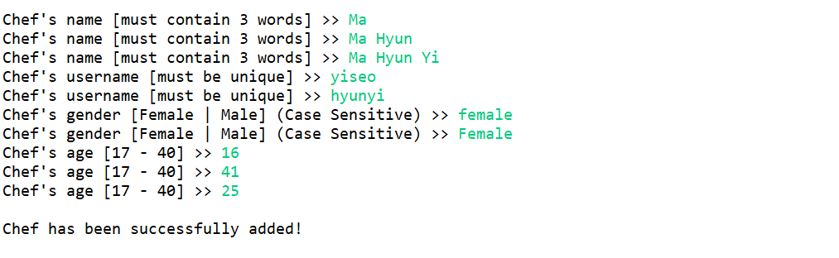
Figure 3. Add Chef

- If the user chooses menu 2 ‘View danbam’s information’, then the program will display the options menu of which information the user want to view:
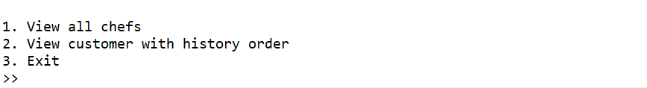
Figure 4. Options Menu
- If the user chooses option 1 ‘View all chefs’ :
- Show all chefs in danbam, with the details of each chef:
- Chef Id
- Chef’s Name
- Chef’s Username
- Chef’s Age
- Chef’s Gender
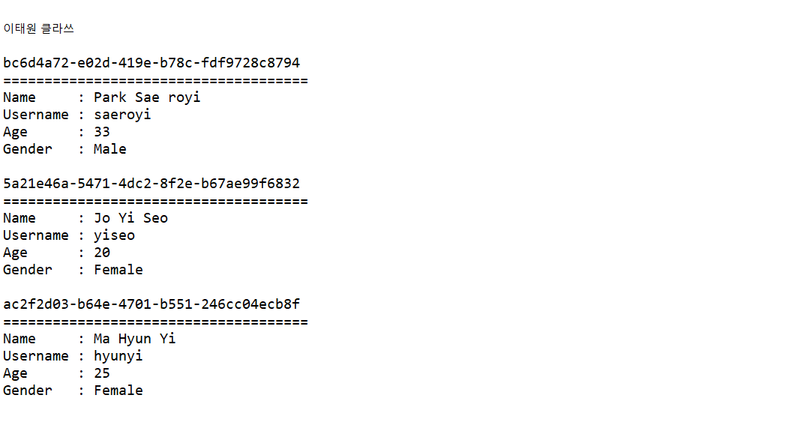
Figure 5. View All Chefs
- User must press enter to exit this view

- If the user chooses option 2 ‘View customer with history order’ :
- If there are none of customers with history order, then view this following message

Figure 6. No Order Messages
- Otherwise display all the customers with history order that ever eat in danbam (This view will be refreshed in every second):
- Customer Id
- Customer’s Name
- Customer’s Age
- Customer’s Gender
- Menu details, with the details of:
- Menu Id
- Menu’s Name
- Total Price (obtained from the sum of menu’s price of the customer’s history orders while eating in danbam
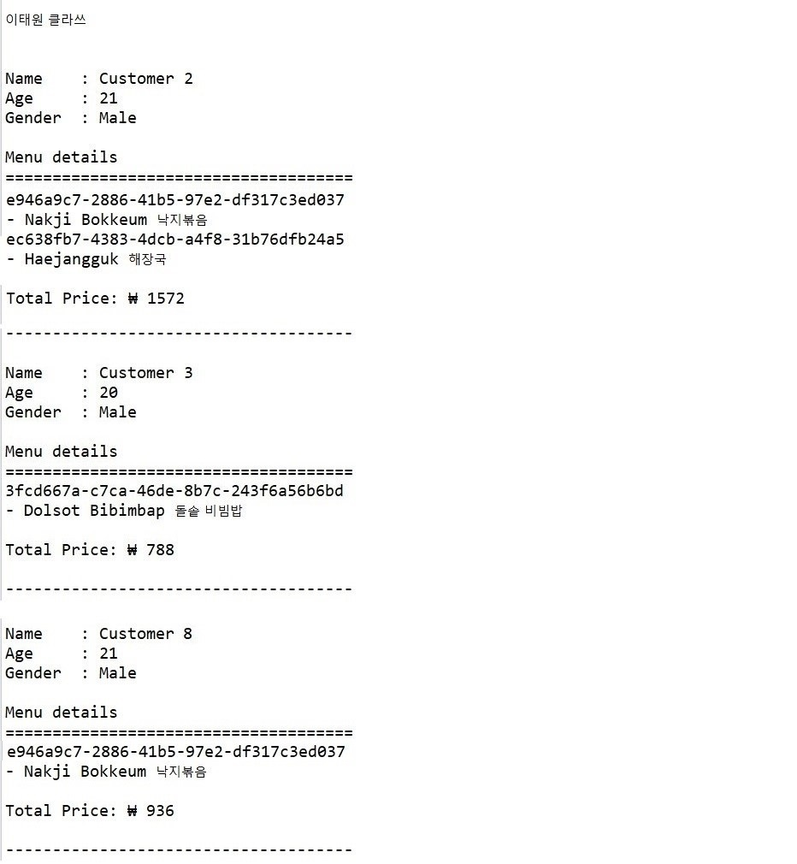
Figure 7. View Customers with History Orders
- User must press enter to exit this view

- If the user chooses option 3 ‘Exit’ :
- Exit the following options and back to the main menu
- If the user chooses menu 3 ‘View customers in danbam’, then:
- Show all the customers (Customer’s Name) in danbam right now:
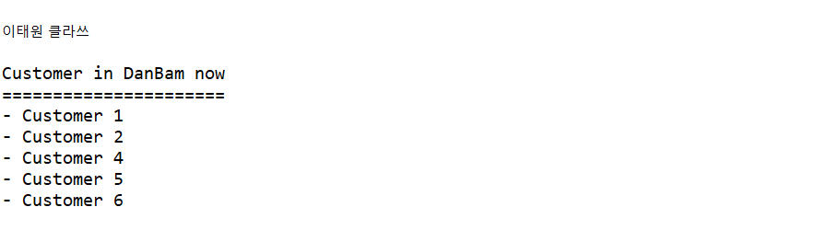
Figure 8. Customer in Danbam
- If the user chooses menu 4 ‘Exit’, then the program will be closed

If there is something you do not understand, feel free to ask your Assistant!

